Curriculum Vitae
Adnan Aftab Nadaf
Email id : adnannadaf3@gmail.com
Contact no : 8007222130


❖ Career Objective:
❖ To secure a challenging position in a reputable organization, to fully utilize my training & skills, while making a significant contribution to the success of company.
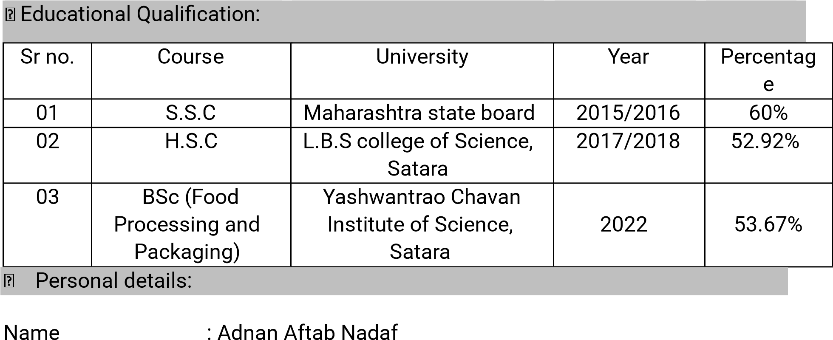
Contact no : 8007222130
Gender : Male
Language known : Hindi, Marathi, English
Nationality : Indian
Marital status : Unmarried
Permanent Address : 15, Guruwar Peth, Satara 415002
Date of Birth : 16/03/2001
❖ Professional skills:
- MS-WORD
- MS-EXCEL
- MS-POWERPOINT
- TALLY
- SPOKEN ENGLISH
- TYPING
❖ Experience :
COMPANY NAME :
ALTRUIST TECHNOLOGIES PVT LTD. PUNE
DESIGNATION: LEAD GENERATION (BPO)
PERIOD : OCTOBER 2022 TO DECEMBER 2022
COMPANY NAME:
COOPER COORPORATION PVT LTD SATARA
DESIGNATION : PRODUCTION SUPERVISOR IN . CENTRIFUGAL FOUNDRY
PERIOD : NOVEMBER 2024 TO JUNE 2025

Strength :
Positive attitude
Team Work
- Quick Learner
- Helping nature
- Honest
❖ Hobbies:
- Playing Outdoor Games
- Swimming
- Horse Riding
- Driving
❖ Declaration:
❖ I here by assure that the above information is true, complete & to the best of my knowledge & belief.
Date: / /
Place:

Adnan Nadaf

